***ISB AMPBA Term-2 Co’24***

**Individual Assignment SA-2**

Author: ***Sudeshna Kundu***

PGID: ***12310045***

Answer of Question 1

Designing Experiment

1. **Randomized Controlled Trial**: Implement a trial where employees are divided randomly in 2 groups, one Treatment Group & Control Group
2. **Treatment Group**: In this group, to enhance IQ scores, there could be trainings, bootcamps, educational seminars for improving Intelligence and cognitive abilities.
3. **Control Group**: This group would get placebo treatment, there would no educational intervention. This helps in isolating the causal effect of IQ intervention effect.

Feasibility of the experiment

1. **Resource Availability:** It should be ensuredthat the necessary resources are available to implement the educational intervention and collect data.
2. **Participant Recruitment:** There should be a decently large number of people on which the experiments could be done.
3. **IQ Enhancement Intervention:** There should be valid & appropriate intervention activities for IQ enhancement.

According to me, the experiment will be ethical if the following measures are considered

Ethical Measures

1. Ensure confidentiality of participants and protect their privacy as well.
2. Provide participants with a debriefing session after the study, explaining the purpose of the experiment.

Answer of Question 2

In the equation where **wage = β0 + β1IQ +u**, the term **u** represents the error term or residuals. This term depicts all the factors other than IQ that affect wages but are not explicitly included in the model. In our case, term **u** can have the causal effect of ***educ***.

Intuitively, we can say that **educ** could be included in that, education can have a causal effect to wage, for example education can give a person more IQ, and more the IQ, more could be the salary.

To see if **educ** is correlated to **IQ** we can check through a scatter plot.

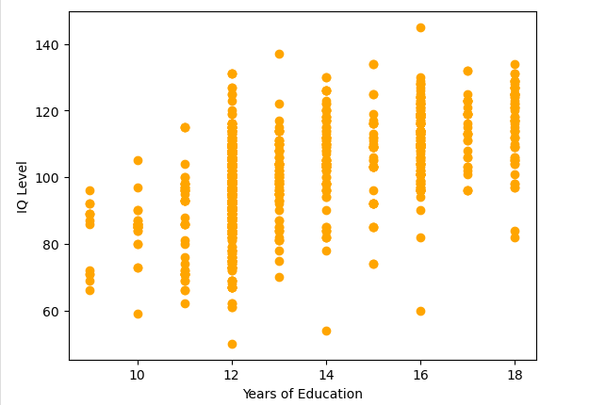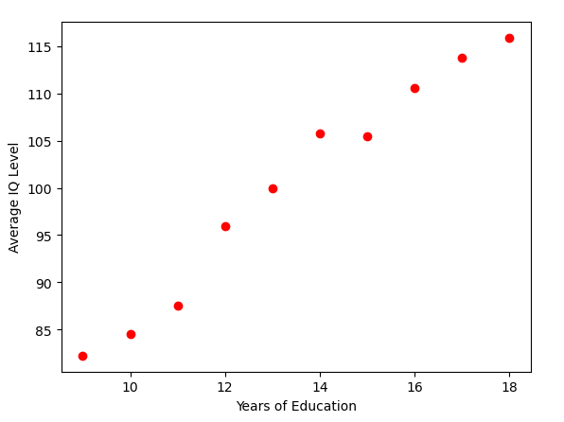

***We can see that there is a correlation, higher the years of education, higher is IQ level on an average.***

Answer of Question 3

In a simple regression model **wage = β0 + β1IQ +u,** estimating the coefficient **β1** using observational data may not be sufficient to uncover the causal effect of IQ on wage. There could be several reasons which are as follows:

1. The variable **u** in the equation represents the error term, which includes all unobserved factors influencing wages but not included in the model. If there are important variables omitted from the model that are correlated with both **iq** and **wage**, the estimated **β1** could be biased.
2. While a simple regression can provide an initial exploration of the relationship between IQ and wages, it may not be sufficient to establish causation due to potential biases. Advanced and careful consideration of study design are crucial to uncovering the causal effect of IQ on wages.

Answer of Question 4

 

Answer of Question 5

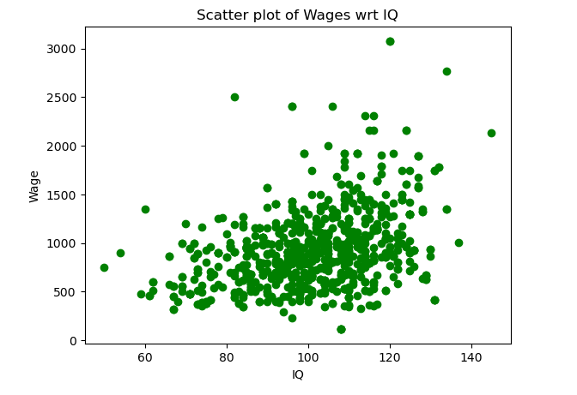 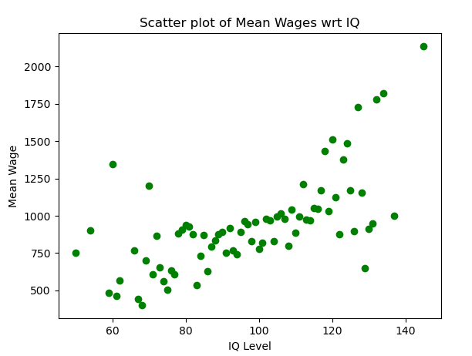

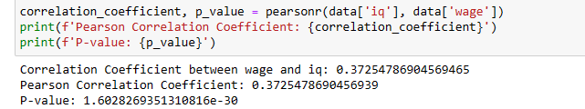

As we can see from the co-efficient of correlation above, there is linearity, there is positive direction, i.e, if IQ increases, wages increase, and there not a great strength since the cluster is not packed tight.

Answer to Question 6

The correlation coefficient between **wage** and **iq** is **0.37255** as depicted below.



Yes, my characterization in part 5, is supporting since it’s a positive coefficient value so the direction is positive, and since the value is not close to 1, therefore the strength is not strong, cluster is not very tight.

Answer to Question 7

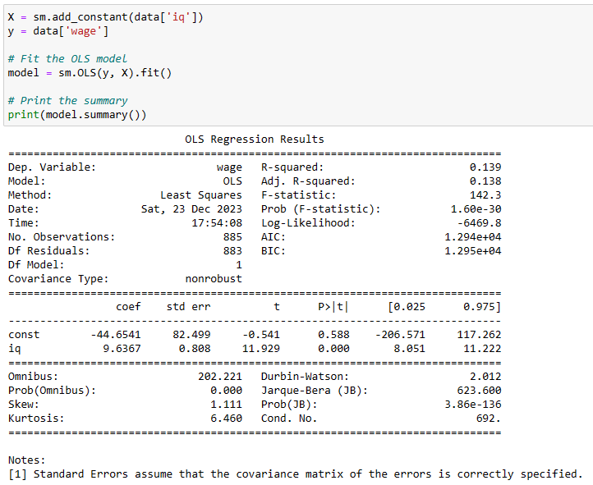

1. The estimated intercept ***β*ˆ0**is: -44.6541
2. The estimated intercept ***β*ˆ1** is: 9.6367

Answer to Question 8

Null Hypothesis -> **H0: β1≠0**

Alternate Hypothesis -> **H1: β1=0**

Answer to Question 9

Yes, we can reject null hypothesis. And we can say, ***IQ is* (linearly) associated with *wage****.*

Explanation: t_statistic = ***β*ˆ1/SE(*β*ˆ1)**

if t_statistic > critical_t_value, we reject null hypothesis

otherwise, we do not reject null hypothesis.

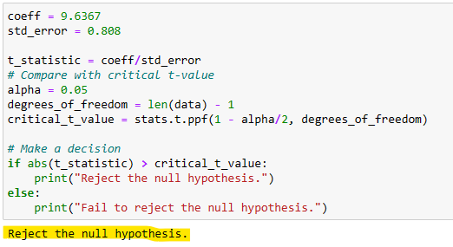

Answer of Question 10

Now, we are estimating that our model is ***wage* = *β*0 + *β*1*IQ* + *β*2*educ* + *u****.*

Yes, this model gives us a more convincing causal effect of **IQ** on **wage** since, **educ** is now considered into the model and it has a co-efficient and is not anymore, a residual term.

1. This relationship is allowing the model to capture complex relationships, considering the joint impact of multiple variables on the dependant variable.
2. This model is giving ***increased predictive accuracy***, a multivariate variate model like above can offer better predictions than a univariate model.

Answer of Question 11



Answer of Question 12

1. The estimated intercept ***β*ˆ0** = -270.2086.

Yes, it makes sense, because the years of education has a very significant relationship with wage, even higher than that of IQ, the intercept has decreased to balance the effect on wage.

1. The estimated coefficients ***β*ˆ1** = 6.3798and ***β*ˆ2** = 41.1528

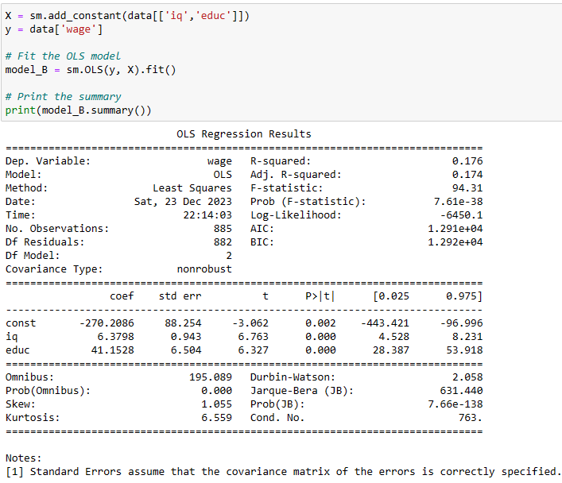

Answer of Question 13

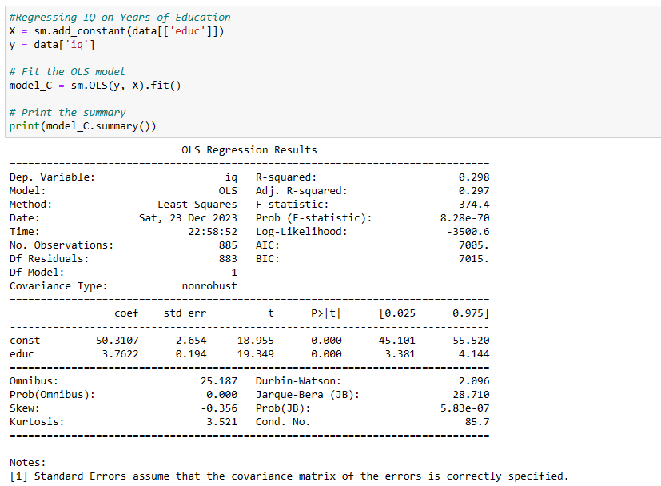

The regressed results are shown above, where **δ˜1** =3.7622, for unit change in the Co-efficient of **educ**, there is 3.7622 times of increase in the co-efficient of **IQ**.

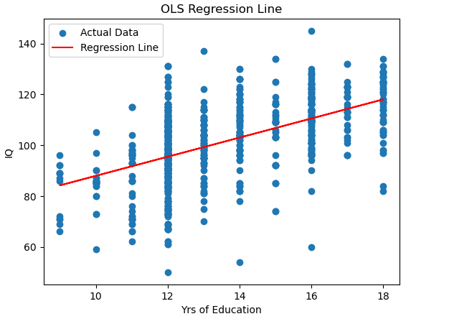

Answer of Question 14

